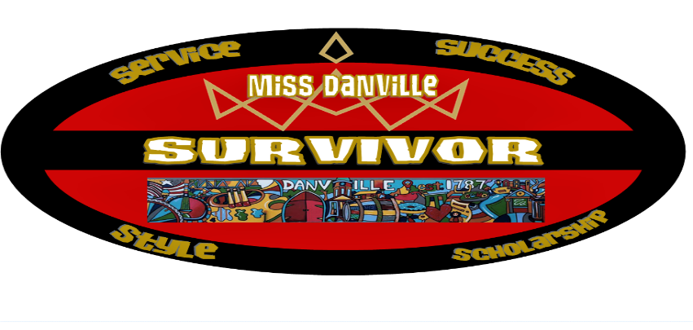

Miss Danville is a SURVIVOR
This is your invitation to become a candidate in the 2022 Miss Danville Outstanding Teen, and Miss Danville Competition. We are planning an exciting event for January 29, 2022, and our venue will be announced soon! Our theme for this year’s competition is “Survivor”. We are all SURVIVORS after surviving the nightmare of the last year! Our hope is that every Candidate will leave our event with more confidence and feeling empowered to become more passionate about their causes, more committed to their goals, and more focused on making positive change in their schools and communities.
****DEADLINE December 31, 2021
Opening Number Attire
Opening number attire for candidates will be an outfit/dress of choice in solid black.
Areas of Competition
Teen Candidates will be judged in Lifestyle and Fitness, Onstage Question, Talent (90 second), Evening Gown, and Private Interview. Miss Contestants will be judged in Social Impact Pitch, Onstage Question, Talent (90 Second), Red Carpet, and Private Interview.
Wanna Know What You’re Playing For?
Both Teen and Miss Contestants will compete for the “Leadership Award” which will go to the contestant who is shown to be a strong leader through her community service and school and community activities. There will also be a “Spirt Award”, and “Community Service Award”, additional awards may be added depending on the number of candidates. The Tribe has spoken, and ALL Miss Candidates will receive a Cash Scholarship!!
NEW THIS YEAR *** All Candidates will need a Miss Danville Prince/Princess. The cost for your Prince/Princess will be $75 and she/he will receive Two tickets to the competition, gift bag, crown, and will have a Pizza Party with Miss America 2013 Mallory Hagan. She/he will appear on stage with each candidate during Evening Gown/Red Carpet
Entry Fees and Other Information
Entry fee for Teen Contestants is $100. There is no entry fee for Miss Contestants, but each must meet the fundraising requirements of the Miss America Organization (will provide details SOON)
This Challenge is On
Each Candidate has the option to sell Ads for the program book. Cost of Ad sales are ¼ page $50.00, ½ page $75.00, and Full Page $150.00. There will be a Cash Scholarship to the candidate that sells the most ADS.
At the end of the night, we will “Tally the Votes” and see who will be the “Ultimate Survivors!!” We will award multiple titles in each division provided candidate numbers meet requirements.
Placement will be decided in the reverse order of the paperwork received. (example first application will compete last in their age group)
Please email all paperwork and headshot to missdanville@gmail.com by the deadline.
Payments should be made through Paypal to missdanville@gmail.com
Best regards,
Reuben Harness and Angela Todd
Executive Co-Directors
Miss Danville Scholarship Organization
Will you be the ultimate Survivor
Miss Danville 2022?
Join us January 29, 2022!

